The Curry-Howard Isomorphism

Student: Chuangjie Xu (1061493)

Supervisor: Achim Jung

January 25, 2011

**Abstract**

**1. Introduction**

Logicians must be familiar with modus ponens $P→Q,P⊢Q$, a very common rule of inference, saying that given implication $P→Q$ and proposition $P$, we have $Q$. Programmers may frequently use function application: if $f$ is a function of type $P→Q$ and $x$ is an argument of type $P$, then the application $f x$ is of type $Q$. Interestingly, modus ponens behaves the same as function application. So, are proofs related to programs? Yes, there is an amazing precise correspondence between them which is described in the Curry-Howard Isomorphism.

In the 1930s, Haskell Curry observed a correspondence between types of combinators and propositions in intuitionist implicational logic. But, at that time, it was viewed as no more than a curiosity. About three decades later, William Howard extended this correspondence to first order logic by introducing dependent types. Therefore, this correspondence is called the Curry-Howard Isomorphism.

The Curry-Howard Isomorphism states a correspondence between systems of formal logic and computational calculi. For years, it has been extended to more expressive logics, e.g. higher order logic, and other mathematical systems, e.g. cartesian closed categories. In this project, I mainly probed into one of its extensions, the three-way-correspondence between intuitionistic propositional logic, simply-typed lambda calculus and cartesian closed categories, with propositions or types being interpreted as objects and proofs or terms as morphisms.

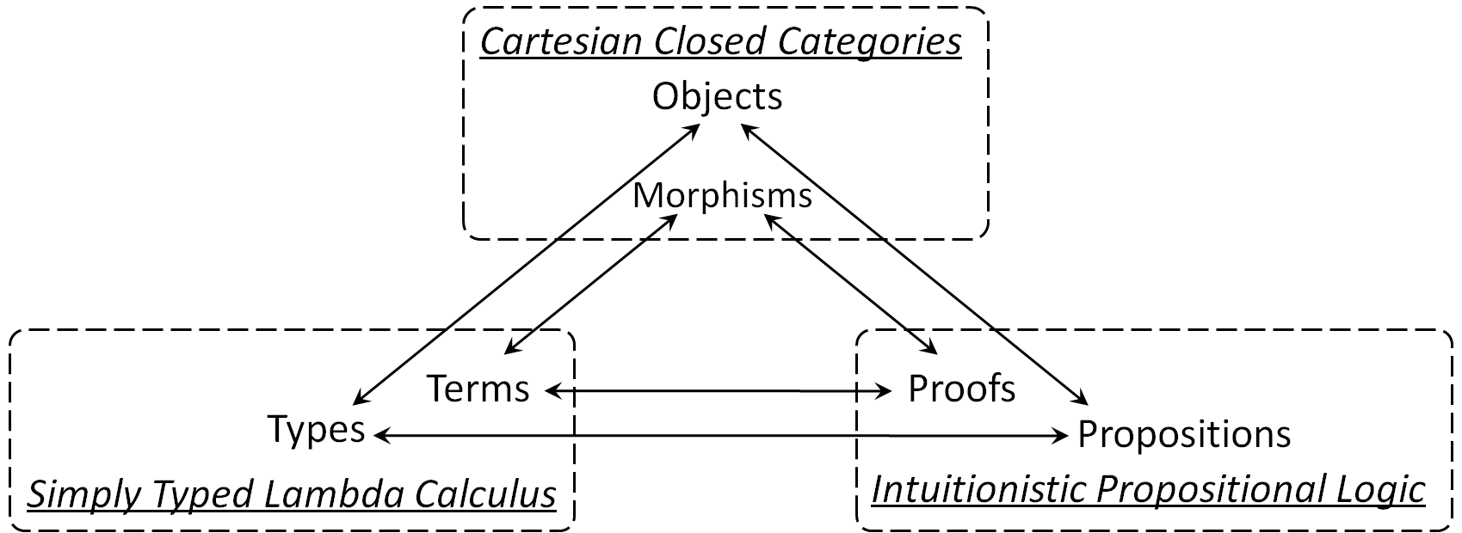

Intuitionistic logic is a formalization of Brouwer’s intuitionism. As the founder of intuitionism, L. E. J. Brouwer avoided use of formal language or logic all his life. But his attitude did not stop others considering formalizations of parts of intuitionism. In the 1930s, Arend Heyting, a former student of Brouwer, produced the first complete axiomatizations for intuitionistic propositional and predicate logic. In intuitionistic logic, the law of excluded middle and double negation elimination are no longer axioms.

The lambda calculus was introduced by Alonzo Church in the early 1930s as a formal system to provide a functional foundation for mathematics. Since Church’s original system was shown to be logically inconsistent, he gave just a consistent subtheory of his original system dealing only with the functional part. Then, in 1940, Church also introduced a typed interpretation of the lambda calculus by assigning types to terms. This typed lambda calculus serves as the foundation of the modern type systems in computer science.

Category first appeared in Samuel Eilenberg and Saunders Mac Lane’s paper written in 1945. It was originally introduced to describe the passage from one type of mathematical structure to another. In recent decades, category theory has found use for computer science. For instant, it has a profound influence on the design of functional and imperative programming languages, e.g. Haskell and Agda.

Looking from the historical perspective, these three different systems seem to have different origins, not related to each other. However, Joachim Lambek showed in the early 1970s that cartesian closed categories provided a formal analogy between proofs in intuitionistic propositional logic and types in combinatory logic. As a result, some people may use Curry-Howard-Lambek Isomorphism to refer to this three-way-correspondence.

**2. Background**

**2.1 Intuitionistic Logic**

**2.2 Lambda Calculus**

**2.3 Categories**

As a relatively young branch of mathematics, category theory studies in an abstract way the properties of particular mathematical structures. It seeks to express all mathematical concepts in terms of “objects” and “morphisms” independently of what they are representing. Nowadays, categories appear in most branches of mathematics and many parts of computer science. Topoi, a kind of category, can even serve as a foundation for mathematics. Cartesian closed categories can work as a framework for describing the denotational semantics of typed lambda calculus, and more generally, programming languages.

**2.3.1 Definition (Categories)** A *category $C$* consists of:

* a collection $C^{o}$ of *objects*;
* a collection $C^{a}$ of *morphisms* (also called *arrows or maps*) between objects, with two maps $dom, cod : C^{a}→C^{o}$ which give the domain and codomain of a morphism (we write $f :a→b$ to denote a morphism $f$ with $dom\left(f\right)=a$ and $cod\left(f\right)=b$);
* a binary map “ $∘$”, called composition, mapping each pair $f,g$ of morphisms with $cod\left(f\right)=dom\left(g\right)$ to a morphism $g∘f$ such that $dom\left(g∘f\right)=dom\left(f\right)$ and $cod\left(g∘f\right)=cod(g)$;

such that the following axioms hold:

* identity: for every object $x$, there exists a morphism ${id}_{x} :x→x$, called the identity morphism for $x$, such that $f=f∘{id}_{a}={id}_{b}∘f$ for any morphism $f :a→b$;
* associativity: $\left(f∘g\right)∘h=f∘\left(g∘h\right)$ for every $f :c→d$, $g :b→c$ and $h :a→b$.

For any objects $a$ and $b$ of a category $C$, the collection of all morphisms $f :a→b$ is called a *hom-set* and denoted as ${Hom}_{C}\left(a,b\right)$. A category is determined by its hom-sets.

Categorists use *diagrams* to express equations. In a diagram, a morphism $f :a→b$ is represented as an arrow form point $a$ to $b$, labeled $f$. A diagram *commutes* if the composition of the morphism along any path between two fixed objects is equal. The identity and associative laws in the definition of category can be represented by the following commutative diagrams:

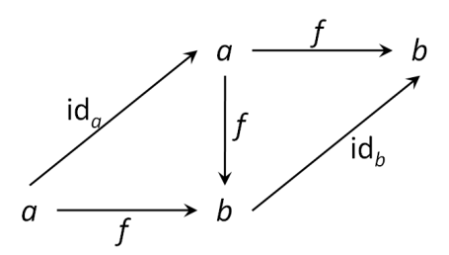 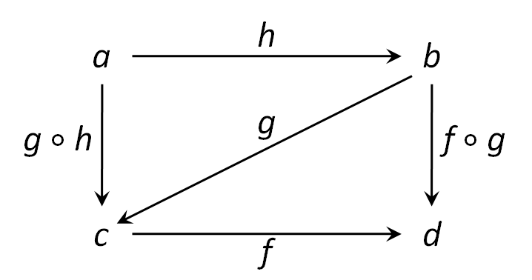

A common example of a category is the category $SET$**.** It is the category whose objects are sets and whose morphisms are functions. The identity of object $S$ in $SET$ is the identity function ${id}_{S} :S→S$. The composition of morphisms is the composition of functions. As a category, it satisfies the two category axioms:

(i) $f=f∘{id}_{A}={id}_{B}∘f$, for every $f :A→B$;

It follows by using the definition of composite function and identity function: $\left(f∘{id}_{A}\right)\left(x\right)=f\left({id}_{A}\left(x\right)\right)=f(x)$ 
 and $\left({id}_{B}∘f\right)\left(x\right)={id}_{B}\left(f\left(x\right)\right)=f(x)$

(ii) $\left(f∘g\right)∘h=f∘\left(g∘h\right)$, for every $f :C→D$, $g :B→C$ and $h :A→B$.

This follows from the fact that composition of functions is associative: $$((f∘g)∘h)(x)=(f∘g)(h(x))=f(g(h(x)))=f((g∘h)(x))=(f∘(g∘h))(x)$$

One typical use of categories is to consider categories whose objects are sets with mathematical structure and whose morphisms are functions that preserve that structure. One of the common examples is the category $POS$ whose objects are posets and whose morphisms are monotone functions. It will be discussed later as an example of a CCC.

There are many categorical constructions, i.e. particular objects and morphisms that satisfy a given set of axioms, which enrich the language of Category Theory. When studying constructions, one observes that all concepts are defined by their relations with other objects, and these relations are established by the existence and the equality of particular morphisms. In this dissertation, the following fundamental categorical constructions will be considered.

The simplest of these is the notion of initial object and its dual, terminal object.

**2.3.2 Definition (Initial and Terminal Objects)** Let $C$ be a category. An object $a$ of $C$ is *initial* if, for any object $b$ in $C$, there is a unique morphism from $a$ to $b$. An object $a$ in $C$ is *terminal* if, for any object $b$ in $C$, there is a unique morphism from $b$ to $a$.

In this dissertation, terminal objects are denoted as $unit$ and, for object $a$, the unique morphism is denoted as ${One}^{a} :a→unit$.

In $SET$, the initial object is the empty set $∅$, and the unique morphism with $∅$ for its source is the empty function whose graph is empty. Any singleton set is terminal in $SET$ since for any set $S$, there is exactly one function from $S$ to this singleton set.

In set theory, we can form a cartesian product of two sets and define coordinate functions for it. Then we can even form a product function of two given functions which have the same domain. This motivates a general definition of categorical products (within a category).

**2.3.3 Definition (Products)** Let $a$ and $b$ be objects of a category $C$. The *product* of $a$ and $b$ is an object $a×b$ together with two morphisms ${Proj}_{1}^{a,b} :a×b→a$ and ${Proj}_{2}^{a,b} :a×b→b$, and for every object $c$ in $C$, an operation $〈 ∙ , ∙ 〉 :Hom\left(c,a\right)×Hom\left(c,b\right)→Hom\left(c,a×b\right)$ such that for all morphisms $f_{1} :c→a$, $f_{2} :c→b$, and $g :c→a×b$, the following equations hold:

* ${Proj}_{i}∘〈f_{1},f_{2}〉=f_{i}$;
* $〈{Proj}_{1}∘g,{Proj}_{2}∘g〉=g$.

Since equations in category theory can be represented by commutative diagrams, we can give another definition of categorical products based on diagrams: Let $a$ and $b$ be objects of category $C$. The *product* of $a$ and $b$ is an object $a×b$ together with two morphisms ${Proj}_{1}^{a,b} :a×b→a$ and ${Proj}_{2}^{a,b} a×b→b$, and for every object $c$ in $C$, an operation $〈 ∙ , ∙ 〉 :Hom\left(c,a\right)×Hom\left(c,b\right)→Hom\left(c,a×b\right)$ such that for every $f_{1} :c→a$ and $f_{2} :c→b$, the morphism $〈f_{1},f_{2}〉 :c→a×b$ is the unique $g$ satisfying

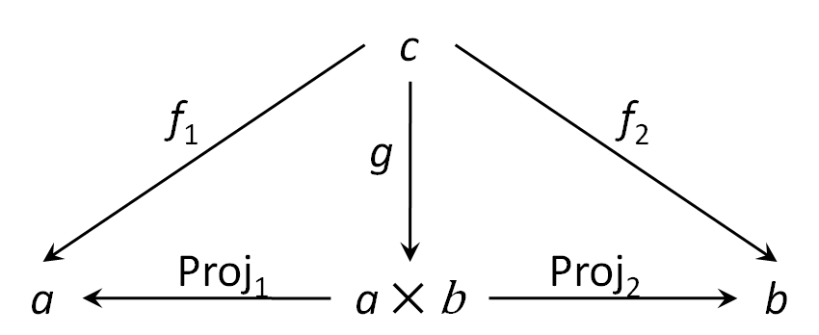

The cartesian product construction for morphisms can also be given a categorical definition. Given morphisms $f :a→c$ and $g :b→d$ the product $f×g :a×b→c×d$ is defined by $f×g=〈f∘{Proj}_{1}^{a,b},g∘{Proj}_{2}^{a,b}〉$ whose correspondent commutative diagram is the following:

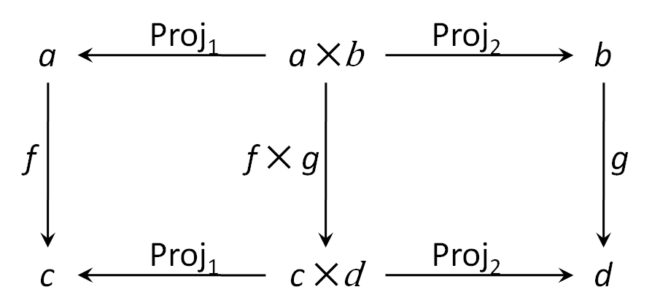

**Proposition** Let $C$ be a category with products. Given $f_{1} :b→c$, $g_{1} :a→b$, $f_{2} :b^{'}→c^{'}$ and $g_{2} :a^{'}→b^{'}$, we have $\left(f_{1}×f_{2}\right)∘\left(g_{1}×g_{2}\right)=\left(f_{1}∘g_{1}\right)×(f_{2}∘g_{2})$.

**Proof**

${Proj}_{1}∘((f_{1}×f_{2})∘(g_{1}×g_{2}))$

$=({Proj}_{1}∘(f_{1}×f_{2}))∘(g_{1}×g_{2})$

$=(f_{1}∘{Proj}_{1})∘(g_{1}×g_{2})$

$=f_{1}∘({Proj}_{1}∘(g_{1}×g_{2}))$

$=f_{1}∘(g_{1}∘{Proj}_{1})$

$=(f_{1}∘g_{1})∘{Proj}_{1}$

Similarly, we have ${Proj}_{2}∘((f_{1}×f_{2})∘(g_{1}×g_{2}))=(f_{2}∘g_{2})∘{Proj}_{2}$.

By the equation $〈{Proj}_{1}∘g,{Proj}_{2}∘g〉=g$ in definition 2.3.3,

$\left(f_{1}×f_{2}\right)∘\left(g_{1}×g_{2}\right)$

$=〈{Proj}_{1}∘((f_{1}×f_{2})∘(g_{1}×g_{2})),{Proj}_{2}∘((f_{1}×f_{2})∘(g_{1}×g_{2}))$

$=〈(f_{1}∘g_{1})∘{Proj}_{1},(f_{2}∘g_{2})∘{Proj}_{2}〉$

According to the definition of products of morphisms,

$\left(f_{1}∘g_{1}\right)×\left(f_{2}∘g_{2}\right)=〈(f_{1}∘g_{1})∘{Proj}_{1},(f_{2}∘g_{2})∘{Proj}_{2}〉$.

Therefore, the equation $\left(f_{1}×f_{2}\right)∘\left(g_{1}×g_{2}\right)=\left(f_{1}∘g_{1}\right)×(f_{2}∘g_{2})$ holds.

□

The products in $SET$ are the cartesian product of sets. Let $A$ and $B$ be two sets. The cartesian product $A×B$ is the set of pair $〈a,b〉$ with $a∈A$ and $b∈B$, together with the coordinate functions ${Proj}_{1} :A×B→A$ and ${Proj}_{2} :A×B→B$ such that ${Proj}_{1}\left(〈a,b〉\right)=a$ and ${Proj}_{21nd }\left(〈a,b〉\right)=b$. Given two functions $f_{1} :C→A$ and $f_{2} :C→B$, the function $〈f_{1},f_{2}〉 :C→A×B$ is defined by $〈f_{1},f_{2}〉(c)=(f_{1}(c),f_{2}(c))$ for all $c∈C$. Then, given $f_{1} :C→A$, $f_{2} :C→B$ and $g :C→A×B$, the equations in definition 2.3.3 are satisfied:

(i) $\left({Proj}_{i}∘〈f_{1},f_{2}〉\right)\left(c\right)$

$={Proj}_{i} (〈f_{1},f_{2}〉(c))$

$={Proj}_{i} (〈f_{1}(c),f_{2}(c)〉)$

$=f_{i}(c)$

(ii) $〈{Proj}_{1}∘g,{Proj}_{2}∘g〉\left(c\right)$

$=〈{Proj}_{1}(g(c)),{Proj}_{2}(g(c))〉$

$=g(c)$

for all $c∈C$.

**2.3.4 Definition (Coproducts)** Let $a$ and $b$ be objects of a category $C$. The *coproduct* of $a$ and $b$ is an object $a+b$ together with morphisms $I_{1}^{a,b} :a→a+b$ and $I_{2}^{a,b} :b→a+b$, and for every object $c$ in $C$ an operation $〈 ∙|∙ 〉 :Hom\left(a,c\right)×Hom\left(b,c\right)→Hom\left(a+b,c\right)$ such that for every $f_{1} :a→c$, $f_{2} :b→c$ and $g :a+b→c$, , the following equations hold:

* $〈f_{1}|f_{2}〉∘I_{i}=f_{i}$;
* $〈g∘I_{1}|g∘I_{2}〉=g$.

The corresponding commutative diagram to the equations above is shown as follows:

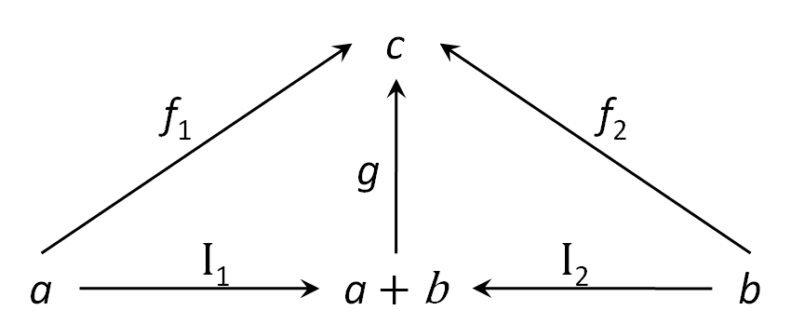

where $〈f_{1}|f_{2}〉 :a+b→c$ is the unique $g$.

The coproducts in $SET$ are the disjoint unions of sets. Let $A$ and $B$ be two sets. The disjoint union of them is defined by $A+B=\left\{\left(a,1\right) | a∈A\right\}∪\left\{\left(b,2\right) | b∈B\right\}$ with two injection functions $I_{1} :A→A+B$ that takes all $a$ in $A$ to $\left(a,1\right)$ in $A+B$ and $I_{2} :B→A+B$ that takes all $b$ in $B$ to $\left(b,2\right)$ in $A+B$. Given two functions $f_{1} :A→C$ and $f_{2} :B→C$, the function $〈f_{1}| f_{2}〉 :A+B→C$ is defined by $〈f_{1}| f_{2}〉((x,i))=f_{i}\left(x\right)$ for all $\left(x,i\right)∈A+B$. Given $f_{1} :A→C$, $f_{2} :B→C$ and $g :A+B→C$, the equations in the definition above are satisfied:

(i) $\left(〈f_{1}|f_{2}〉∘I_{i}\right)\left(x\right)$

$=〈f_{1}|f_{2}〉(I_{i}(x))$

$=〈f_{1}|f_{2}〉((x,i))$

$=f_{i}(x)$

(ii) $〈g∘I_{1}|g∘I_{2}〉((x,i))$

$=\left(g∘I_{i}\right)\left(x\right)$

$=g(I_{i}(x))$

$=g((x,i))$

for all $(x,i)∈A+B$.

One can form a set of functions which have the same domain and codomain. Similarly, the hom-set of morphisms may form an object. This idea brings our last basic construction, exponentials.

**2.3.5 Definition (Exponentials)** Let $C$ be a category with products for all objects, and $a$ and $b$ be objects of $C$. The *exponential*, also called *function object*, of $a$ and $b$ is an object $a→b$ together with a morphism $App :\left(a→b\right)×a→b$, and for every object $c$ in $C$, an operation $Curry :Hom\left(c×a,b\right)→Hom\left(c,a→b\right)$ such that for every $h :c×a→b$ and $k :c→\left(a→b\right)$, the following equations hold:

* $App∘〈Curry\left(h\right)∘{Proj}_{1},{Proj}_{2}〉=h$;
* $Curry\left(App∘〈k∘{Proj}_{1},{Proj}_{2}〉\right)=k$.

Using product of morphisms $f×g=〈f∘{Proj}_{1},g∘{Proj}_{2}〉$, the two equations above can be rewritten as $App∘(Curry(h)×id)=h$ and $Curry(App∘(k×id))=k$.

The commutative diagram representing the equations in the definition is shown as follows:

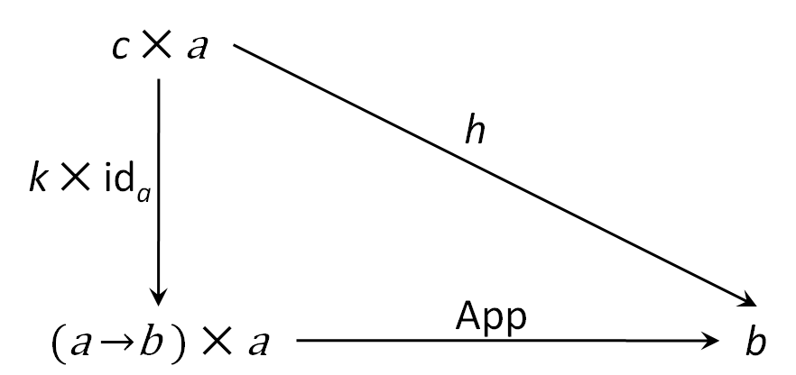

where the morphism $Curry\left(h\right) : c→\left(a→b\right)$ is the unique $k$.

In $SET$, the exponent set $A→B$ of $A$ and $B$ is the set of functions from $A$ to $B$. The function $App :\left(A→B\right)×A→B$ is given by $App(〈f,a〉)=f\left(a\right)$ for all $f :A→B$ and $a∈A$. Given a function $g :C×A→B$, the function $Curry\left(g\right)$ is defined by $((Curry(g))(c))(a)=g(〈c,a〉)$ for all $c∈C$ and $a∈A$. Given $h :C×A→B$ and $k :C→\left(A→B\right)$, the two equations hold:

(i) $\left(App∘〈Curry\left(h\right)∘{Proj}_{1},{Proj}_{2}〉\right)(〈c,a〉)$

$=App(〈Curry(h)∘{Proj}_{1},{Proj}_{2}〉(〈c,a〉))$

$=App((Curry(h)∘{Proj}_{1})(〈c,a〉),{Proj}_{2}(〈c,a〉))$

$=App((Curry(h)(c),a))$

$=(Curry(h)(c))(a)$

$=h(〈c,a〉)$

(ii) $((Curry(App∘〈k∘{Proj}_{1},{Proj}_{2}〉))(c))(a)$

$=(App∘〈k∘{Proj}_{1},{Proj}_{2}〉)(〈c,a〉)$

$=App(〈k∘{Proj}_{1},{Proj}_{2}〉(〈c,a〉))$

$=App((k∘{Proj}_{1})(〈c,a〉),{Proj}_{2}(〈c,a〉))$

$=App((k(c),a))$

$=(k(c))(a)$

for all $a∈A$ and $c∈C$.

Both products and exponentials have special importance for theories of computation. A two-argument function can be reduced to a one-argument function yielding a function from the second argument to the result. This passage is called *currying*. And exponentials give a categorical interpretation to the notion of currying. Therefore, categories with products and exponentials for every pair of objects are important enough to deserve a special name.

**2.3.6 Definition (Cartesian Closed Categories)** A category $C$ is *cartesian closed* iff

* It contains a terminal object $unit$;
* For all objects $a$ and $b$ in $C$, there is a product;
* For all objects $a$ and $b$ in $C$, there is an exponential.

**Proposition** The following two useful identities hold in all cartesian closed categories:

(i) $〈f,g〉∘h=〈f∘h,g∘h〉$

where $f :c→a$, $g :c→b$ and $h :d→c$;

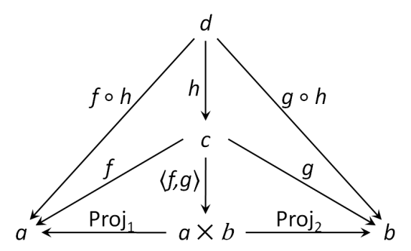

(ii) $Curry(f)∘h=Curry(f∘(h×{id}_{a}))$

where $f :a×b→c$ and $h :d→a$.

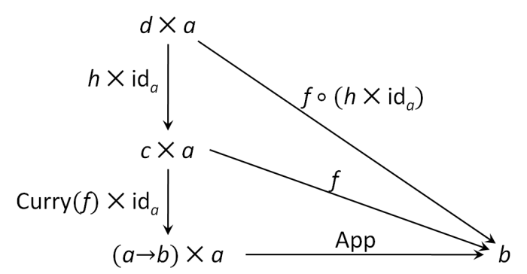

**Proof**

These two equations have been proved by the diagrams following them. But they can also be proved by the equations given in definition 2.3.3 and definition 2.3.5:

(i) ${Proj}_{1}∘\left(〈f,g〉∘h\right)=\left({Proj}_{1}∘〈f,g〉\right)∘h=f∘h$

${Proj}_{2}∘\left(〈f,g〉∘h\right)=\left({Proj}_{2}∘〈f,g〉\right)∘h=g∘h$

$〈{Proj}_{1}∘\left(〈f,g〉∘h\right),{Proj}_{2}∘\left(〈f,g〉∘h\right)〉=〈f∘h,g∘h〉$

Since we have $〈{Proj}_{1}∘g,{Proj}_{2}∘g〉=g$, then $〈f,g〉∘h=〈f∘h,g∘h〉$ holds.

(i) $f=App∘(Curry(f)×{id}_{a}))$ (by $App∘(Curry(h)×id))=h$)

$Curry(f∘(h×{id}_{a}))$

$=Curry((App∘(Curry(f)×{id}_{a})))∘(h×{id}_{a}))$

$=Curry(App∘((Curry(f)×{id}_{a}))∘(h×{id}_{a})))$

(by $\left(f_{1}×f_{2}\right)∘\left(g_{1}×g_{2}\right)=\left(f_{1}∘g_{1}\right)×(f_{2}∘g_{2})$)

$=Curry(App∘((Curry(f)∘h)×({id}_{a}∘{id}_{a})))$

$=Curry(App∘((Curry(f)∘h)×{id}_{a}))$

(by $Curry(App∘(k×id))=k$)

$=Curry(f)∘h$

□

The following gives some examples and one non-example of CCCs.

(1) $SET$

$SET$ has been already given as an example of each categorical construction. It is cartesian closed since it satisfies the three conditions:

* Any singleton set can be the terminal object (it does not matter which one it exactly is since all the singleton sets are isomorphic);
* The product of sets $A$ and $B$ is the cartesian product of $A$ and $B$;
* The exponential of sets $A$ and $B$ is the set of functions from $A$ to $B$.

(2) $POS$

$POS$ is the category whose objects are posets and whose morphisms are monotone maps. The identity of object $A=\left(A,≤_{A}\right)$ in $POS$ is the identity map ${id}^{A} :A→A$ such that ${id}^{A}\left(a\right)=a$ for all $a∈A$. The composition of morphisms is the composition of maps which still preserves the monotonicity property.

$POS$ is cartesian closed:

* Any singleton poset can be the terminal object $unit$. The map ${One}^{A} :A→unit$ from any poset $A=\left(A,≤_{A}\right)$ in $POS$ to this singleton poset is unique.
* The product $A×B=\left(A×B,≤_{A×B}\right)$ of posets $A=\left(A,≤_{A}\right)$ and $B=\left(B,≤_{B}\right)$ is the cartesian product of set $A$ and $B$ with the ordering $≤_{A×B}$ which is defined by $\left(a,b\right)≤_{A×B}\left(a^{'},b^{'}\right)$ iff $a≤_{A}a^{'}$ and $b≤_{B}b^{'}$. The projections are the coordinate functions ${Proj}_{1}^{A,B} :A×B→A$ and ${Proj}_{2}^{A,B} :A×B→B$. Given two monotone maps $f_{1} :A→B$ and $f_{2} :A→C$, the map $〈f_{1},f_{2}〉 :A→B×C$ is defined by $〈f_{1},f_{2}〉(a)=(f_{1}(a),f_{2}(a))$ for all $a∈A$. Suppose $a,a^{'}∈A$ and $a≤a'$, then $f_{1}\left(a\right)≤f_{1}\left(a^{'}\right)$ and $f_{2}\left(a\right)≤f_{2}\left(a^{'}\right)$. According to the definition of $〈⋅,⋅〉$, we have $〈f_{1},f_{2}〉\left(a\right)≤〈f_{1},f_{2}〉\left(a^{'}\right)$, therefore, the map $〈f_{1},f_{2}〉$ is monotone. In the same way as $SET$, $POS$ satisfies the equations in definition 2.3.3.
* The object $A→B=\left(A→B,≤_{A→B}\right)$ is a poset consisting of the set of monotone maps from $A$ to $B$ and a ordering $≤_{A→B}$ defined by, given $f,f^{'}: A→B$, $f≤_{A→B}f^{'}$ iff $f\left(a\right)≤_{B}f^{'}\left(a\right)$ for all $a∈A$. Given $g :A×B→C$, the map $Curry\left(g\right) :A→\left(B→C\right)$ is defined by $((Curry(g))(a))(b)=g((a,b))$ for all $a∈A$ and $b∈B$. Suppose $a,a^{'}∈A$, $b∈B$ and $a≤_{A}a^{'}$, we have $(Curry(g))(a)≤_{B→C}(Curry(g))(a^{'})$ because $((Curry(g))(a))(b)=g((a,b))≤_{C}g(a^{'},b)=((Curry(g))(a^{'}))(b)$; therefore, the map $Curry\left(g\right)$ is monotone. The map ${App}^{B,C} :\left(B→C\right)×B→C$ is defined by $App((h,b))=h\left(b\right)$ for all $h :B→C$ and $b∈B$. Suppose $h,h^{'} :B→C$ and $b,b^{'}∈B$ with $h≤_{B→C}h^{'}$ and $b≤_{B}b^{'}$, then $(h,b)≤_{\left(B→C\right)×B}(h',b')$ by the definition of $≤_{\left(B→C\right)×B}$ and $App((h,b))=h\left(b\right)≤_{C}h\left(b^{'}\right)≤_{C}h^{'}\left(b^{'}\right)=App((h^{'},b^{'}))$; therefore, $App$ is also monotone. $POS$ satisfies the equations in definition 2.3.5. The proof is carried out in the same way of $SET$.

(3) ${POS}_{⊥}$

${POS}_{⊥}$ is same as the category $POS$ except that each poset has a least element $⊥$. We construct its identity, composition, terminal object, product, exponential in the same way of $POS$**.** Since the categorical constructions of morphism still preserve the monotonicity of morphisms; therefore, ${POS}_{⊥}$ is cartesian closed.

(4) ${POS}_{⊥}!$– non-example

${POS}_{⊥}!$ is the category whose objects are posets with least element $⊥$ and whose morphisms are monotone maps with the property that $⊥$ in one poset is mapped to $⊥$ in another one, i.e. for any monotone map $f :A→B$, $f\left(⊥\right)=⊥$.

However, ${POS}_{⊥}!$ is not cartesian closed. It has terminal object. But it does not have products and exponentials. Suppose that the products in ${POS}_{⊥}!$ are constructed in the same way of $POS$**.** (the monotonicity cannot be preserved)

**3. Correspondences**

**3.1 Every type-derivation in $λ^{→}$ leads to a proof in intuitionist implicational logic**

**3.2 Every proof in intuitionist propositional logic can be encoded by a lambda term**

**3.3 Every lambda term can be interpreted as a morphism in a CCC**

As mentioned in the previous section, cartesian closed categories can work as a more general but also more abstract framework for describing the denotational semantics of typed lambda calculus.

The lambda calculus $λ^{ unit,×,→}$ has terminal type, product types and function types. Correspondently, a CCC has terminal object, products and exponentials. A closed relation between them seems to be obvious. However, the lambda calculus $λ^{ →}$ without product type constructor is as expressive as $λ^{ unit,×,→}$. Therefore, both the type expressions and well-typed lambda terms in $λ^{ →}$ can be interpreted in any CCC, and this interpretation should be sound and complete.

**3.3.1 Definition (The Interpretation of Terms)** Given a typed lambda calculus $λ^{ →}$ and a cartesian closed category $C$, we choose an object of $C$ for each type constant and a morphism for each term constant, and then all type expressions and typing contexts can be interpreted as objects and well-typed terms as morphisms. For notational simplicity, $C⟦ ⟧$ is omitted to denote the interpretation of type expressions, typing contexts and terms of $λ^{ →}$ in $C$:

(1) The interpretation $C⟦σ⟧$ of type expression $σ$ is defined as follows:

* $C⟦b⟧$ $=\hat{b}$, given as an object constant in $C$;
* $C⟦σ→τ⟧$ $=C⟦σ⟧→C⟦τ⟧$.

(2) The interpretation $C⟦Γ⟧$ of typing context $Γ$ is defined by induction on the length of the context:

* $C⟦∅⟧$ $=unit$;
* $C⟦Γ,x :σ⟧$ $=C⟦Γ⟧×C⟦σ⟧$.

(3) The interpretation $C⟦Γ⊳M :σ⟧$ of a well-typed term is a morphism from $C⟦Γ⟧$ to $C⟦σ⟧$ which is defined by induction on the proof of the typing judgement $Γ⊳M :σ$:

* $C⟦x :σ⊳x :σ⟧$ $={Proj}_{2}^{unit, σ}$;
* $C⟦∅⊳c :σ⟧$ $=\hat{c} :unit→⟦σ⟧$, given as a morphism constant in $C$;
* $C⟦Γ⊳MN :τ⟧$ $={App}^{σ,τ}∘〈C⟦Γ⊳M :σ→τ⟧,C⟦Γ⊳N :σ⟧〉$;
* $C⟦Γ⊳λx:σ.M :σ→τ⟧$ $=Curry\left(C⟦Γ,x :σ⊳M :τ⟧\right)$;
* $C⟦Γ_{1},x :σ,Γ_{2}⊳M :τ⟧$ $=C⟦Γ_{1},Γ_{2}⊳M :τ⟧∘χ_{f}^{⟦Γ_{1},x:σ,Γ_{2}⟧}$ where ${\left(Γ_{1},x:σ,Γ_{2}\right)}_{f}=Γ_{1},Γ_{2}$ and $Γ_{1}⋃Γ_{2}$ contains all the free variables of $M$.

In this definition, $f :\left\{1,…,m\right\}→\left\{1,…,n\right\}$ is an *m*,*n*-function. If $Γ=x_{1}σ_{1},…,x_{n}σ_{n}$ is an ordered type assignment of length $n$, the ordered type assignment $Γ_{f}$ of length $m$ is defined by $Γ_{f}=x_{f\left(1\right)}σ_{f\left(1\right)},…,x_{f\left(m\right)}σ_{f\left(m\right)}$. If $Γ⊳M :σ$ is a well-typed term and $Γ_{f}$ contains all the free variables of $M$, then the interpretation of $Γ_{f}⊳M :σ$ can be related to the one of $Γ⊳M :σ$ by using a combination $χ_{f}^{⟦Γ⟧} : ⟦Γ⟧→⟦Γ_{f}⟧$ of pairing and projection functions.

Before giving the definition of the combination, we need a few notational conventions. If $h_{i} :a→a_{i}$ is a morphism from object $a$ to $a_{i}$, for $1≤i≤n$, then we write $〈h_{1},…,h_{n}〉$ for the morphism $〈h_{1},…,h_{n}〉=〈〈〈h_{1},h_{2}〉,…〉,h_{n}〉 :a→(((a_{1}×a_{2})×…)×a_{n})$ and ${Proj}_{i}^{a_{1}×a_{2}×…×a_{n}} :a_{1}×a_{2}×…×a_{n}→a_{i}$ for a composition of projection morphisms ${Proj}_{1}$ and ${Proj}_{2}$ so that ${Proj}_{i}^{a_{1}×a_{2}×…×a_{n}}∘〈h_{1},…,h_{n}〉=h_{i}$.

Now, given an *m*,*n*-function $f$, we can define $χ_{f}^{unit×a_{1}×…×a_{n}}$ by

$χ_{f}^{unit×a_{1}×…×a_{n}}=〈{One}^{unit×a_{1}×…×a_{n}},{Proj}_{f\left(1\right)+1}^{unit×a_{1}×…×a_{n}},…,{Proj}_{f\left(m\right)+1}^{unit×a_{1}×…×a_{n}}〉$

$:unit×a_{1}×…×a_{n}→unit×a_{f\left(1\right)}×…×a_{f\left(m\right)}$.

The type terminal object $unit$ is included in the type of $χ_{f}$ since the interpretation of any typing context contains $unit$.

Some lemmas are needed in the proof of soundness and completeness of the interpretation defined in 3.3.1.

The first one is the substitution lemma, which will be used in the proof of soundness later.

**3.3.2 Lemma (CCC Substitution)** If $Γ,x :σ⊳M :τ$ and $Γ⊳N :σ$ are well-typed terms, then $⟦Γ⊳\left[N/x\right]M :τ⟧=⟦Γ,x :σ⊳M :τ⟧∘〈{id}_{⟦Γ⟧},⟦Γ⊳N :σ⟧〉$.

**Proof**

The proof is carried out by induction on typing derivation $Γ,x :σ⊳M :τ$. The base case is the one whose term is a term variable. The inductive steps have two cases: application and abstraction.

**Base case $Γ,x :σ⊳x :σ$**

$⟦Γ⊳\left[N/x\right]M :τ⟧=⟦Γ⊳\left[N/x\right]x :σ⟧=⟦Γ⊳N :σ⟧$

$⟦Γ,x :σ⊳M :τ⟧∘〈{id}_{⟦Γ⟧},⟦Γ⊳N :σ⟧〉$

$=⟦Γ,x :σ⊳x :σ⟧∘〈{id}_{⟦Γ⟧},⟦Γ⊳N :σ⟧〉$

$={Proj}_{2}^{⟦Γ⟧,σ}∘〈{id}_{⟦Γ⟧},⟦Γ⊳N :σ⟧〉$ (by ${Proj}_{i}∘〈f_{1},f_{2}〉=f_{i}$)

$=⟦Γ⊳N :σ⟧$

**Inductive steps**

**(1) Application $Γ,x :σ⊳M_{1}M_{2} :τ_{2}$**

Induction hypothesis:

$⟦Γ⊳\left[N/x\right]M_{1} :τ_{1}→τ_{2}⟧=⟦Γ,x:σ⊳M_{1} :τ_{1}→τ_{2}⟧∘〈{id}_{⟦Γ⟧},⟦Γ⊳N:σ⟧〉$ and

$⟦Γ⊳\left[N/x\right]M_{2} :τ_{1}⟧=⟦Γ,x:σ⊳M_{2} :τ_{1}⟧∘〈{id}_{⟦Γ⟧},⟦Γ⊳N:σ⟧〉$.

$⟦Γ⊳\left[N/x\right]M :τ⟧=⟦Γ⊳\left[N/x\right]M_{1}M_{2} :τ_{2}⟧$

$={App}^{τ_{1},τ_{2}}∘〈⟦Γ⊳\left[N/x\right]M_{1} :τ_{1}→τ_{2}⟧,⟦Γ⊳\left[N/x\right]M_{2} :τ_{1}⟧〉$

$={App}^{τ_{1},τ_{2}}∘\left(〈⟦Γ,x:σ⊳M_{1} :τ_{1}→τ_{2}⟧,⟦Γ,x:σ⊳M_{2} :τ_{1}⟧〉∘〈{id}_{⟦Γ⟧},⟦Γ⊳N:σ⟧〉\right)$

$=\left({App}^{τ_{1},τ_{2}}∘〈⟦Γ,x:σ⊳M_{1} :τ_{1}→τ_{2}⟧,⟦Γ,x:σ⊳M_{2} :τ_{1}⟧〉\right)∘〈{id}_{⟦Γ⟧},⟦Γ⊳N:σ⟧〉$

$=⟦Γ,x:σ⊳M_{1}M_{2} :τ_{2}⟧∘〈{id}_{⟦Γ⟧},⟦Γ⊳N:σ⟧〉$

$=⟦Γ,x:σ⊳M :τ⟧∘〈{id}_{⟦Γ⟧},⟦Γ⊳N:σ⟧〉$

**(2) Abstraction $Γ,x :σ⊳λy:ρ.M^{'} :ρ→τ$**

Induction hypothesis:

$⟦Γ,y:ρ⊳\left[N/x\right]M^{'} :τ⟧$

$=⟦Γ,y:ρ,x:σ⊳M^{'} :τ⟧∘〈{id}_{⟦Γ,y:ρ⟧},⟦Γ,y:ρ⊳N:σ⟧〉$

$=\left(⟦Γ,x:σ,y:ρ⊳M^{'} :τ⟧∘χ_{f}^{⟦Γ,y:ρ,x:σ⟧}\right)∘〈{id}_{⟦Γ,y:ρ⟧},⟦Γ,y:ρ⊳N:σ⟧〉$

$=⟦Γ,x:σ,y:ρ⊳M^{'} :τ⟧∘\left(χ_{f}^{⟦Γ,y:ρ,x:σ⟧}∘〈{id}_{⟦Γ,y:ρ⟧},⟦Γ,y:ρ⊳N:σ⟧〉\right)$

$=⟦Γ,x:σ,y:ρ⊳M^{'} :τ⟧∘\left(〈{id}_{⟦Γ⟧},⟦Γ⊳N:σ⟧〉×{id}_{⟦y:ρ⟧}\right)$

$⟦Γ⊳\left[N/x\right]M :τ⟧=⟦Γ⊳\left[N/x\right]\left(λy:ρ.M^{'}\right) :ρ→τ⟧$

$=⟦Γ⊳λy:ρ.\left[N/x\right]M^{'} :ρ→τ⟧$

$=Curry\left(⟦Γ,y:ρ⊳\left[N/x\right]M^{'} :τ⟧\right)$

$=Curry\left(⟦Γ,x:σ,y:ρ⊳M :τ⟧∘\left(〈{id}_{⟦Γ⟧},⟦Γ⊳N:σ⟧〉×{id}_{⟦y:ρ⟧}\right)\right)$

(by $Curry(f∘(h×id))=Curry(f)∘h$)

$=Curry\left(⟦Γ,x:σ,y:ρ⊳M :τ⟧\right)∘〈{id}_{⟦Γ⟧},⟦Γ⊳N:σ⟧〉$

$=⟦Γ,x:σ⊳λy:ρ.M :ρ→τ⟧∘〈{id}_{⟦Γ⟧},⟦Γ⊳N:σ⟧〉$

□

**3.3.3 Theorem (Soundness)** Given any well-typed terms $Γ⊳M :σ$ and $Γ⊳N :σ$ with $M≡_{αβη}N$, then the interpretations of them are same, i.e. $⟦Γ⊳M :σ⟧=⟦Γ⊳N :σ⟧$, in every CCC.

**Proof**

**(1) $α$-equivalence**

During the interpretation, we can see that the names of term variables never appear in the interpretation; therefore, $α$-equivalence should hold in the interpretation. Here, an equational proof of a stronger form of $α$-equivalence is given.

If $x_{1}:σ_{1},…,x_{k}:σ_{k}⊳M :σ$ and $y_{1}:σ_{1},..,y_{k}:σ_{k}⊳N :σ$ are well-typed, with $N≡_{α}\left[y_{1},…,y_{k}/x_{1},…,x_{k}\right]M$, then $⟦x_{1}:σ_{1},…,x_{k}:σ_{k}⊳M:σ⟧=⟦y_{1}:σ_{1},..,y_{k}:σ_{k}⊳N:σ⟧.$

The proof can be carried out by induction on the term $M :σ$. The base case is the one when $M$ is a variable while the inductive steps contains application and abstraction.

Base case – $M :σ=x_{i}:σ_{i}$

$⟦x_{1}:σ_{1},…,x_{k}:σ_{k}⊳M :σ⟧$

$=⟦x_{1}:σ_{1},…,x_{k}:σ_{k}⊳x_{i}:σ_{i}⟧$

$={Proj}_{i+1}^{unit,σ_{1},…,σ_{k}}$

$⟦y_{1}:σ_{1},..,y_{k}:σ_{k}⊳N :σ⟧$

$=⟦y_{1}:σ_{1},..,y_{k}:σ_{k}⊳\left[y_{1},…,y_{k}/x_{1},…,x_{k}\right]M⟧$

$=⟦y_{1}:σ_{1},..,y_{k}:σ_{k}⊳\left[y_{1},…,y_{k}/x_{1},…,x_{k}\right]x_{i}:σ_{i}⟧$

$=⟦y_{1}:σ_{1},..,y_{k}:σ_{k}⊳y_{i}:σ_{i}⟧$

$={Proj}_{i+1}^{unit,σ_{1},…,σ_{k}}$

$⟦x_{1}:σ_{1},…,x_{k}:σ_{k}⊳x_{i}:σ_{i}⟧=⟦y_{1}:σ_{1},..,y_{k}:σ_{k}⊳\left[y_{1},…,y_{k}/x_{1},…,x_{k}\right]x_{i}:σ_{i}⟧$

Inductive steps:

(a) Application – $M :σ=M_{1}M_{2} :τ_{2}$

$N=N_{1}N_{2}$ with $N_{1}≡_{α}\left[y_{1},…,y_{k}/x_{1},…,x_{k}\right]M_{1}$ and $N_{2}≡_{α}\left[y_{1},…,y_{k}/x_{1},…,x_{k}\right]M_{2}$.

Induction hypothesis:

$⟦x_{1}:σ_{1},…,x_{k}:σ_{k}⊳M_{1} :τ_{1}→τ_{2}⟧=⟦y_{1}:σ_{1},..,y_{k}:σ_{k}⊳N_{1} :τ_{1}→τ_{2}⟧$ and

$⟦x_{1}:σ_{1},…,x_{k}:σ_{k}⊳M_{2} :τ_{1}⟧=⟦y_{1}:σ_{1},..,y_{k}:σ_{k}⊳N_{2} :τ_{1}⟧$

$⟦x_{1}:σ_{1},…,x_{k}:σ_{k}⊳M :σ⟧$

$=⟦x_{1}:σ_{1},…,x_{k}:σ_{k}⊳M_{1}M_{2} :τ_{2}⟧$

$={App}^{τ_{1},τ_{2}}∘〈⟦x_{1}:σ_{1},…,x_{k}:σ_{k}⊳M_{1} :τ_{1}→τ_{2}⟧,⟦x_{1}:σ_{1},…,x_{k}:σ_{k}⊳M_{2} :τ_{1}⟧〉$

$={App}^{τ_{1},τ_{2}}∘〈⟦y_{1}:σ_{1},..,y_{k}:σ_{k}⊳N_{1} :τ_{1}→τ_{2}⟧,⟦y_{1}:σ_{1},..,y_{k}:σ_{k}⊳N_{2} :τ_{1}⟧〉$

$=⟦y_{1}:σ_{1},..,y_{k}:σ_{k}⊳N_{1}N_{2} :τ_{2}⟧$

$=⟦y_{1}:σ_{1},..,y_{k}:σ_{k}⊳N :σ⟧$

(b) Abstraction – $M :σ=λx_{k+1}:σ_{k+1}.M^{'}: σ_{k+1}→σ$

$N=λy_{k+1}:σ_{k+1}.N^{'}$ with $N^{'}=\left[y_{1},…,y_{k+1}/x_{1},…,x_{k+1}\right]M^{'}$

Induction hypothesis:

$⟦x_{1}:σ_{1},…,x_{k+1}:σ_{k+1}⊳M^{'} :σ⟧=⟦y_{1}:σ_{1},..,y_{k+1}:σ_{k+1}⊳N^{'} :σ⟧$

$⟦x_{1}:σ_{1},…,x_{k}:σ_{k}⊳M :σ⟧$

$=⟦x_{1}:σ_{1},…,x_{k}:σ_{k}⊳λx_{k+1}:σ_{k+1}.M^{'}: σ_{k+1}→σ⟧$

$=Curry\left(⟦x_{1}:σ_{1},…,x_{k}:σ_{k},x_{k+1}:σ_{k+1}⊳M^{'} :σ⟧\right)$

$=Curry\left(⟦y_{1}:σ_{1},…,y_{k}:σ_{k},y_{k+1}:σ_{k+1}⊳N^{'} :σ⟧\right)$

$=⟦y_{1}:σ_{1},..,y_{k}:σ_{k}⊳λy_{k+1}:σ_{k+1}.N^{'}: σ_{k+1}→σ⟧$

$=⟦y_{1}:σ_{1},..,y_{k}:σ_{k}⊳N :σ⟧$

Therefore, $⟦x_{1}:σ_{1},…,x_{k}:σ_{k}⊳M:σ⟧=⟦y_{1}:σ_{1},..,y_{k}:σ_{k}⊳N:σ⟧$.

**(2) $β$-equivalence**

We can represent $β$-equivalence in the following form:

$Γ⊳\left(λx:σ.M\right)N :τ≡_{β}Γ⊳\left[N/x\right]M :τ⟹ ⟦Γ⊳\left(λx:σ.M\right)N :τ⟧=⟦Γ⊳\left[N/x\right]M :τ⟧$

$⟦Γ⊳\left(λx:σ.M\right)N :τ⟧$

$=App∘〈⟦Γ⊳λx:σ.M :σ→τ⟧,⟦Γ⊳N :σ⟧〉$

$=App∘〈Curry\left(⟦Γ,x:σ⊳M :τ⟧\right),⟦Γ⊳N :σ⟧〉$ (by $〈f, g〉=\left(f×id\right)∘〈id, g〉$)

$=App∘\left(Curry\left(⟦Γ,x:σ⊳M :τ⟧\right)×id\right)∘〈id,⟦Γ⊳N :σ⟧〉$

(by $App∘\left(Curry\left(h\right)×id\right)=h$)

$=⟦Γ,x:σ⊳M :τ⟧∘〈id,⟦Γ⊳N :σ⟧〉$ (by Substitution Lemma)

$=⟦Γ⊳\left[N/x\right]M :τ⟧$

**(3) $η$-equivalence**

We can represent $η$-equivalence in the following form:

$Γ⊳λx:σ.Mx :τ≡_{η}Γ⊳M :σ→τ⟹ ⟦Γ⊳λx:σ.Mx :τ⟧=⟦Γ⊳M :σ→τ⟧$

$⟦Γ⊳λx:σ.Mx :τ⟧$

$=Curry\left(⟦Γ,x:σ⊳Mx :τ⟧\right)$

$=Curry\left(App∘〈⟦Γ,x:σ⊳M :σ→τ⟧,⟦Γ,x:σ⊳x:σ⟧〉\right)$

(by $⟦Γ,x:σ⊳M :τ⟧=⟦Γ⊳M :τ⟧∘{Proj}_{1}^{⟦Γ⟧,σ}$ and $⟦Γ,x:σ⊳x:σ⟧={Proj}_{2}^{⟦Γ⟧,σ}$)

$=Curry\left(App∘〈⟦Γ⊳M :σ→τ⟧∘{Proj}_{1}^{⟦Γ⟧,σ},{Proj}_{2}^{⟦Γ⟧,σ}〉\right)$

(by $Curry\left(App∘〈k∘{Proj}_{1},{Proj}_{2}〉\right)=k$)

$=⟦Γ⊳M :σ→τ⟧$

□

**3.3.4 Theorem (Completeness)** Given any well-typed terms $Γ⊳M:σ$ and $Γ⊳N :σ$, there exists a CCC $C$ such that if $C⟦Γ⊳M:σ⟧= C⟦Γ⊳N :σ⟧$, then $Γ⊳M≡_{αβη}N :σ$.

**Proof**

The category $C$ is generated by $λ^{ →}$ in the following way:

The objects of $C$ are sequences of type expressions. To be specific, the empty sequence is the terminal object $unit$ and a sequence $σ_{1},σ_{2},…,σ_{n}$ is the product of these types. For notational convenience, we write ${\vec{x}}_{k}$ for a sequence $x_{1},x_{2},…,x_{k}$ of $k$ variables, similarly ${\vec{σ}}_{k}$ for a sequence of $k$ type expressions, and ${\vec{x}}_{k}:{\vec{σ}}_{k}$ for typing context $x_{1} :σ_{1},…,x_{k}:σ_{k}$.

The morphisms from ${\vec{σ}}_{m}$ to ${\vec{τ}}_{n}$ are given by $n$-tuples of terms over $m$ free variables. To put it more specifically, a morphism ${\vec{σ}}_{m}→{\vec{τ}}_{n}$ is an equivalence class of tuples of terms,

$\left[{\vec{x}}_{m}:{\vec{σ}}_{m}⊳M_{i} :τ_{i} | i=1,…,n\right]$

$=\left[{\vec{x}}_{m}:{\vec{σ}}_{m}⊳M_{1} :τ_{1},…,{\vec{x}}_{m}:{\vec{σ}}_{m}⊳M_{n} :τ_{n}\right]$

$=\left\{〈{\vec{x}}_{m}:{\vec{σ}}_{m}⊳N_{1} :τ_{1},…,{\vec{x}}_{m}:{\vec{σ}}_{m}⊳N_{n} :τ_{n}〉 | {\vec{x}}_{m}:{\vec{σ}}_{m}⊳M_{i} :τ_{i}=N_{i} :τ_{i} for i=1,…,n\right\}$.

Composition in $C$ is defined by substitution. Given morphisms ${\vec{τ}}_{m}→{\vec{ρ}}_{n}$ and ${\vec{σ}}_{l}→{\vec{τ}}_{m}$, the composition of them is

$\left[{\vec{y}}_{m}:{\vec{τ}}_{m}⊳N_{i} :ρ_{i} | i=1,…,n\right]∘\left[{\vec{x}}_{l}:{\vec{σ}}_{l}⊳M_{i} :τ_{i} | i=1,…,m\right]$

$=\left[{\vec{x}}_{l}:{\vec{σ}}_{l}⊳\left[{\vec{y}}_{m}/{\vec{M}}_{m}\right]N_{i} :ρ_{i} | i=1,…,n\right] :{\vec{σ}}_{l}→{\vec{ρ}}_{n}$

**(1) $C$ is cartesian closed**

The cartesian closed structure of $C$ is obtained as follows:

**i)** Terminal object $unit$ with unique morphism $One$

As mentioned above, the empty sequence of types is the terminal object $unit$. According to the definition of morphisms above, a morphism from an object to ${\vec{τ}}_{n}$ is given by $n$-tuples of terms. Then, the morphism from an object to $unit$, the empty sequence, should be given by the empty tuple. For every object ${\vec{σ}}_{k}$, the morphism $One :{\vec{σ}}_{k}→unit$ is defined by the empty tuple, i.e. $One=\left[ \right]$. Clearly, it is unique for every object ${\vec{σ}}_{k}$.

**ii)** Product objects with projection morphisms and function $〈∙,∙〉$

Given two objects ${\vec{σ}}_{m}$ and ${\vec{τ}}_{n}$, the product of them is obtained by their concatenation, $σ_{1},…,σ_{m},τ_{1},…,τ_{n}$. Then, the projection morphisms is given by

${Proj}_{1}^{{\vec{σ}}_{m},{\vec{τ}}_{n}}=\left[{\vec{x}}_{m}:{\vec{σ}}_{m},{\vec{y}}_{n}:{\vec{τ}}_{n}⊳x_{i}:σ_{i} | i=1,…,m\right] :{\vec{σ}}_{m}×{\vec{τ}}_{n}→{\vec{σ}}_{m}$

${Proj}_{2}^{{\vec{σ}}_{m},{\vec{τ}}_{n}}=\left[{\vec{x}}_{m}:{\vec{σ}}_{m},{\vec{y}}_{n}:{\vec{τ}}_{n}⊳y_{i}:τ_{i} | i=1,…,m\right] :{\vec{σ}}_{m}×{\vec{τ}}_{n}→{\vec{τ}}_{n}$

And, given $\left[{\vec{x}}_{l}:{\vec{σ}}_{l}⊳M_{i}:τ_{i} | i=1,…,m\right] :{\vec{σ}}_{l}→{\vec{τ}}_{m}$ and $\left[{\vec{x}}_{l}:{\vec{σ}}_{l}⊳N_{i}:ρ_{i} | i=1,…,n\right] :{\vec{σ}}_{l}→{\vec{ρ}}_{n}$, the product function $〈∙,∙〉$ is defined by the concatenation of tuples:

$〈\left[{\vec{x}}_{l}:{\vec{σ}}_{l}⊳M_{i}:τ_{i} | i=1,…,m\right],\left[{\vec{x}}_{l}:{\vec{σ}}_{l}⊳N_{i}:ρ_{i} | i=1,…,n\right]〉$

$=\left[{\vec{x}}_{l}:{\vec{σ}}_{l}⊳M_{1}:τ_{1},…,{\vec{x}}_{l}:{\vec{σ}}_{l}⊳M_{m}:τ_{m}, {\vec{x}}_{l}:{\vec{σ}}_{l}⊳N_{1}:ρ_{1},…,{\vec{x}}_{l}:{\vec{σ}}_{l}⊳N_{n}:ρ_{n}\right] :{\vec{σ}}_{l}→{\vec{τ}}_{m}×{\vec{ρ}}_{n}$

The equations in definition 2.3.3 are satisfied. For any

$f_{1}=\left[{\vec{x}}_{l}:{\vec{σ}}_{l}⊳M_{i}:τ_{i} | i=1,…,m\right] :{\vec{σ}}_{l}→{\vec{τ}}_{m}$,

$f_{2}=\left[{\vec{x}}_{l}:{\vec{σ}}_{l}⊳N_{i}:ρ_{i} | i=1,…,n\right]:{\vec{σ}}_{l}→{\vec{ρ}}_{n}$, and

$g =\left[{\vec{x}}_{l}:{\vec{σ}}_{l}⊳M_{1}:τ_{1},…,{\vec{x}}_{l}:{\vec{σ}}_{l}⊳M_{m}:τ_{m},{\vec{x}}_{l}:{\vec{σ}}_{l}⊳N_{1}:ρ_{1},…,{\vec{x}}_{l}:{\vec{σ}}_{l}⊳N_{n}:ρ_{n}\right] :{\vec{σ}}_{l}→{\vec{τ}}_{m}×{\vec{ρ}}_{n}$,

we have

${Proj}_{1}^{{\vec{τ}}_{m},{\vec{ρ}}_{n}}∘〈f_{1},f_{2}〉$

$=\left[{\vec{y}}_{m}:{\vec{τ}}_{m},{\vec{z}}_{n}:{\vec{ρ}}_{n}⊳y_{i}:τ_{i} | i=1,…,m\right]∘$

$〈\left[{\vec{x}}_{l}:{\vec{σ}}_{l}⊳M_{i}:τ_{i} | i=1,…,m\right],\left[{\vec{x}}_{l}:{\vec{σ}}_{l}⊳N_{i}:ρ_{i} | i=1,…,n\right]〉$

$=\left[{\vec{y}}_{m}:{\vec{τ}}_{m},{\vec{z}}_{n}:{\vec{ρ}}_{n}⊳y_{i}:τ_{i} | i=1,…,m\right]∘$

$\left[{\vec{x}}_{l}:{\vec{σ}}_{l}⊳M_{1}:τ_{1},…,{\vec{x}}_{l}:{\vec{σ}}_{l}⊳M_{m}:τ_{m},{\vec{x}}_{l}:{\vec{σ}}_{l}⊳N_{1}:ρ_{1},…,{\vec{x}}_{l}:{\vec{σ}}_{l}⊳N_{n}:ρ_{n}\right]$

$=\left[{\vec{x}}_{l}:{\vec{σ}}_{l}⊳\left[{\vec{y}}_{m},{\vec{z}}_{n}/{\vec{M}}_{m},{\vec{N}}_{n}\right]y_{i}:τ_{i} | i=1,…,m\right]$

$=\left[{\vec{x}}_{l}:{\vec{σ}}_{l}⊳M_{i}:τ_{i} | i=1,…,m\right]$

$=f_{1}$

Similarly, we have ${Proj}_{2}^{{\vec{τ}}_{m},{\vec{ρ}}_{n}}∘〈f_{1},f_{2}〉=f_{2}$

$〈{Proj}_{1}^{{\vec{τ}}_{m},{\vec{ρ}}_{n}}∘g,{Proj}_{2}^{{\vec{τ}}_{m},{\vec{ρ}}_{n}}∘g〉$

$=〈\left[{\vec{y}}_{m}:{\vec{τ}}_{m},{\vec{z}}_{n}:{\vec{ρ}}_{n}⊳y_{i}:τ_{i} | i=1,…,m\right]∘$

$\left[{\vec{x}}_{l}:{\vec{σ}}_{l}⊳M_{1}:τ_{1},…,{\vec{x}}_{l}:{\vec{σ}}_{l}⊳M_{m}:τ_{m},{\vec{x}}_{l}:{\vec{σ}}_{l}⊳N_{1}:ρ_{1},…,{\vec{x}}_{l}:{\vec{σ}}_{l}⊳N_{n}:ρ_{n}\right],{Proj}_{2}^{{\vec{τ}}_{m},{\vec{ρ}}_{n}}∘g〉$

$=〈\left[{\vec{x}}_{l}:{\vec{σ}}_{l}⊳\left[{\vec{y}}_{m},{\vec{z}}_{n}/{\vec{M}}_{m},{\vec{N}}_{n}\right]y_{i}:τ_{i} | i=1,…,m\right],{Proj}_{2}^{{\vec{τ}}_{m},{\vec{ρ}}_{n}}∘g〉$

$=〈\left[{\vec{x}}_{l}:{\vec{σ}}_{l}⊳M_{i}:τ_{i} | i=1,…,m\right],{Proj}_{2}^{{\vec{τ}}_{m},{\vec{ρ}}_{n}}∘g〉$

$=〈\left[{\vec{x}}_{l}:{\vec{σ}}_{l}⊳M_{i}:τ_{i} | i=1,…,m\right],\left[{\vec{x}}_{l}:{\vec{σ}}_{l}⊳N_{i}:ρ_{i} | i=1,…,n\right]〉$

$=\left[{\vec{x}}_{l}:{\vec{σ}}_{l}⊳M_{1}:τ_{1},…,{\vec{x}}_{l}:{\vec{σ}}_{l}⊳M_{m}:τ_{m},{\vec{x}}_{l}:{\vec{σ}}_{l}⊳N_{1}:ρ_{1},…,{\vec{x}}_{l}:{\vec{σ}}_{l}⊳N_{n}:ρ_{n}\right]$

$=g$

**iii)** Exponentials with function $Curry$ and morphism $App$

The exponential of objects ${\vec{σ}}_{m}$ and ${\vec{τ}}_{n}$ is the sequence of types of the following pattern ${\vec{σ}}_{m}→{\vec{τ}}_{n}=σ_{1}→…→σ_{m}→τ_{1},…,σ_{1}→…→σ_{m}→τ_{n}$.

Given any $h=\left[{\vec{x}}_{l}:{\vec{σ}}_{l},{\vec{y}}_{m}:{\vec{τ}}_{m}⊳M_{i}:ρ_{i} | i=1,…,n\right] :{\vec{σ}}_{l}×{\vec{τ}}_{m}→{\vec{ρ}}_{n}$, the morphism $Curry(h)$ is defined by

$Curry\left(h\right)$

$=Curry\left(\left[{\vec{x}}_{l}:{\vec{σ}}_{l},{\vec{y}}_{m}:{\vec{τ}}_{m}⊳M_{i}:ρ_{i} | i=1,…,n\right]\right)$

$=\left[{\vec{x}}_{l}:{\vec{σ}}_{l}⊳λ{\vec{y}}_{m}:{\vec{τ}}_{m}.M_{i}:τ_{i}→…→τ_{m}→ρ_{i} | i=1,…,n\right] :{\vec{σ}}_{l}→\left({\vec{τ}}_{m}→{\vec{ρ}}_{n}\right)$

For any ${\vec{σ}}_{m}$ and ${\vec{τ}}_{n}$, the morphism ${App}^{{\vec{σ}}_{m},{\vec{τ}}_{n}}$ is defined by

${App}^{{\vec{σ}}_{m},{\vec{τ}}_{n}}$

$=\left[{\vec{f}}_{n}:{\vec{σ}}_{m}→{\vec{τ}}_{n},{\vec{x}}_{m}:{\vec{σ}}_{m}⊳f_{i} x_{1}… x_{m} :τ_{i} | i=1,…,n\right] :\left({\vec{σ}}_{m}→{\vec{τ}}_{n}\right)×{\vec{σ}}_{m}→{\vec{τ}}_{n}$

The equations in definition 2.3.5 should hold. For any $h=\left[{\vec{x}}_{l}:{\vec{σ}}_{l},{\vec{y}}_{m}:{\vec{τ}}_{m}⊳M_{i}:ρ_{i} | i=1,…,n\right] :{\vec{σ}}_{l}×{\vec{τ}}_{m}→{\vec{ρ}}_{n}$ 
 and $k=\left[{\vec{x}}_{l}:{\vec{σ}}_{l}⊳λ{\vec{y}}_{m}:{\vec{τ}}_{m}.M_{i}:τ_{i}→…→τ_{m}→ρ_{i} | i=1,…,n\right] :{\vec{σ}}_{l}→\left({\vec{τ}}_{m}→{\vec{ρ}}_{n}\right)$  
,

we have

${App}^{{\vec{τ}}_{m},{\vec{ρ}}_{n}}∘〈Curry\left(h\right)∘{Proj}_{1}^{{\vec{σ}}_{l},{\vec{τ}}_{m}},{Proj}_{2}^{{\vec{σ}}_{l},{\vec{τ}}_{m}}〉$

$=\left[{\vec{f}}_{n}:{\vec{τ}}_{m}→{\vec{ρ}}_{n},{\vec{z}}_{m}:{\vec{τ}}_{m}⊳f_{i} z_{1}… z_{m}:ρ_{i} | i=1,…,n\right]∘$

$〈Curry\left(\left[{\vec{x}}_{l}:{\vec{σ}}_{l},{\vec{y}}_{m}:{\vec{τ}}_{m}⊳M_{i}:ρ_{i} | i=1,…,n\right]\right)∘\left[{\vec{x}}_{l}:{\vec{σ}}_{l},{\vec{y}}_{m}:{\vec{τ}}_{m}⊳x_{i}:σ_{i} | i=1,…,l\right],$

$\left[{\vec{x}}_{l}:{\vec{σ}}_{l},{\vec{y}}_{m}:{\vec{τ}}_{m}⊳y_{i}:τ_{i} | i=1,…,m\right]〉$

$=\left[{\vec{f}}_{n}:{\vec{τ}}_{m}→{\vec{ρ}}_{n},{\vec{z}}_{m}:{\vec{τ}}_{m}⊳f_{i} z_{1}… z_{m}:ρ_{i} | i=1,…,n\right]∘$

$〈\left[{\vec{x}}_{l}:{\vec{σ}}_{l}⊳λ{\vec{y}}_{m}:{\vec{τ}}_{m}.M_{i}:τ_{i}→…→τ_{m}→ρ_{i} | i=1,…,n\right]∘$

$\left[{\vec{x}}_{l}:{\vec{σ}}_{l},{\vec{y}}_{m}:{\vec{τ}}_{m}⊳x_{i}:σ_{i} | i=1,…,l\right],\left[{\vec{x}}_{l}:{\vec{σ}}_{l},{\vec{y}}_{m}:{\vec{τ}}_{m}⊳y_{i}:τ_{i} | i=1,…,m\right]〉$

$=\left[{\vec{f}}_{n}:{\vec{τ}}_{m}→{\vec{ρ}}_{n},{\vec{z}}_{m}:{\vec{τ}}_{m}⊳f_{i} z_{1}… z_{m}:ρ_{i} | i=1,…,n\right]∘$

$〈\left[{\vec{x}}_{l}:{\vec{σ}}_{l},{\vec{y}}_{m}:{\vec{τ}}_{m}⊳\left[{\vec{x}}_{l}/{\vec{x}}_{l}\right]\left(λ{\vec{y}}_{m}:{\vec{τ}}_{m}.M_{i}\right):τ_{1}→…→τ_{m}→ρ_{i} | i=1,…,n\right],$

$\left[{\vec{x}}_{l}:{\vec{σ}}_{l},{\vec{y}}_{m}:{\vec{τ}}_{m}⊳y_{1}:τ_{1},…,{\vec{x}}_{l}:{\vec{σ}}_{l},{\vec{y}}_{m}:{\vec{τ}}_{m}⊳y_{m}:τ_{m}\right]〉$

$=\left[{\vec{f}}_{n}:{\vec{τ}}_{m}→{\vec{ρ}}_{n},{\vec{z}}_{m}:{\vec{τ}}_{m}⊳f_{i} z_{1}… z_{m}:ρ_{i} | i=1,…,n\right]∘$

$〈\left[{\vec{x}}_{l}:{\vec{σ}}_{l},{\vec{y}}_{m}:{\vec{τ}}_{m}⊳λ{\vec{y}}_{m}:{\vec{τ}}_{m}.M_{i}:τ_{1}→…→τ_{m}→ρ_{i} | i=1,…,n\right],$

$\left[{\vec{x}}_{l}:{\vec{σ}}_{l},{\vec{y}}_{m}:{\vec{τ}}_{m}⊳y_{1}:τ_{1},…,{\vec{x}}_{l}:{\vec{σ}}_{l},{\vec{y}}_{m}:{\vec{τ}}_{m}⊳y_{m}:τ_{m}\right]〉$

$=\left[{\vec{f}}_{n}:{\vec{τ}}_{m}→{\vec{ρ}}_{n},{\vec{z}}_{m}:{\vec{τ}}_{m}⊳f_{i} z_{1}… z_{m}:ρ_{i} | i=1,…,n\right]∘$

$[{\vec{x}}_{l}:{\vec{σ}}_{l},{\vec{y}}_{m}:{\vec{τ}}_{m}⊳λ{\vec{y}}_{m}:{\vec{τ}}_{m}.M_{1}:τ_{1}→…→τ_{m}→ρ_{1},…,$

${\vec{x}}_{l}:{\vec{σ}}_{l},{\vec{y}}_{m}:{\vec{τ}}_{m}⊳λ{\vec{y}}_{m}:{\vec{τ}}_{m}.M_{n}:τ_{1}→…→τ_{m}→ρ_{n},$

${\vec{x}}_{l}:{\vec{σ}}_{l},{\vec{y}}_{m}:{\vec{τ}}_{m}⊳y_{1}:τ_{1},…,{\vec{x}}_{l}:{\vec{σ}}_{l},{\vec{y}}_{m}:{\vec{τ}}_{m}⊳y_{m}:τ_{m}]$

$=\left[{\vec{x}}_{l}:{\vec{σ}}_{l},{\vec{y}}_{m}:{\vec{τ}}_{m}⊳\left[{\vec{f}}_{n},{\vec{z}}_{m}/λ{\vec{y}}_{m}:{\vec{τ}}_{m}.M_{1},…,λ{\vec{y}}_{m}:{\vec{τ}}_{m}.M_{n},{\vec{y}}_{m}\right]\left(f_{i} z_{1}… z_{m}\right):ρ_{i} | i=1,…,n\right]$

$=\left[{\vec{x}}_{l}:{\vec{σ}}_{l},{\vec{y}}_{m}:{\vec{τ}}_{m}⊳M_{i}:ρ_{i} | i=1,…,n\right]$

$=h$

$Curry\left({App}^{{\vec{τ}}_{m},{\vec{ρ}}_{n}}∘〈k∘{Proj}_{1}^{{\vec{σ}}_{l},{\vec{τ}}_{m}},{Proj}_{2}^{{\vec{σ}}_{l},{\vec{τ}}_{m}}〉\right)$

$=Curry(\left[{\vec{f}}_{n}:{\vec{τ}}_{m}→{\vec{ρ}}_{n},{\vec{z}}_{m}:{\vec{τ}}_{m}⊳f_{i} z_{1}… z_{m}:ρ_{i} | i=1,…,n\right]∘$

$〈\left[{\vec{x}}_{l}:{\vec{σ}}_{l}⊳λ{\vec{y}}_{m}:{\vec{τ}}_{m}.M_{i}:τ_{i}→…→τ_{m}→ρ_{i} | i=1,…,n\right]∘$

$\left[{\vec{x}}_{l}:{\vec{σ}}_{l},{\vec{y}}_{m}:{\vec{τ}}_{m}⊳x_{i}:σ_{i} | i=1,…,l\right], \left[{\vec{x}}_{l}:{\vec{σ}}_{l},{\vec{y}}_{m}:{\vec{τ}}_{m}⊳y_{i}:τ_{i} | i=1,…,m\right]〉)$

$=Curry(\left[{\vec{f}}_{n}:{\vec{τ}}_{m}→{\vec{ρ}}_{n},{\vec{z}}_{m}:{\vec{τ}}_{m}⊳f_{i} z_{1}… z_{m}:ρ_{i} | i=1,…,n\right]∘$

$〈\left[{\vec{x}}_{l}:{\vec{σ}}_{l},{\vec{y}}_{m}:{\vec{τ}}_{m}⊳\left[{\vec{x}}_{l}/{\vec{x}}_{l}\right]\left(λ{\vec{y}}_{m}:{\vec{τ}}_{m}.M_{i}\right):τ_{1}→…→τ_{m}→ρ_{i} | i=1,…,n\right],$

$\left[{\vec{x}}_{l}:{\vec{σ}}_{l},{\vec{y}}_{m}:{\vec{τ}}_{m}⊳y_{1}:τ_{1},…,{\vec{x}}_{l}:{\vec{σ}}_{l},{\vec{y}}_{m}:{\vec{τ}}_{m}⊳y_{m}:τ_{m}\right]〉)$

$=Curry(\left[{\vec{f}}_{n}:{\vec{τ}}_{m}→{\vec{ρ}}_{n},{\vec{z}}_{m}:{\vec{τ}}_{m}⊳f_{i} z_{1}… z_{m}:ρ_{i} | i=1,…,n\right]∘$

$〈\left[{\vec{x}}_{l}:{\vec{σ}}_{l},{\vec{y}}_{m}:{\vec{τ}}_{m}⊳λ{\vec{y}}_{m}:{\vec{τ}}_{m}.M_{i}:τ_{1}→…→τ_{m}→ρ_{i} | i=1,…,n\right],$

$\left[{\vec{x}}_{l}:{\vec{σ}}_{l},{\vec{y}}_{m}:{\vec{τ}}_{m}⊳y_{1}:τ_{1},…,{\vec{x}}_{l}:{\vec{σ}}_{l},{\vec{y}}_{m}:{\vec{τ}}_{m}⊳y_{m}:τ_{m}\right]〉)$

$=Curry(\left[{\vec{f}}_{n}:{\vec{τ}}_{m}→{\vec{ρ}}_{n},{\vec{z}}_{m}:{\vec{τ}}_{m}⊳f_{i} z_{1}… z_{m}:ρ_{i} | i=1,…,n\right]∘$

$[{\vec{x}}_{l}:{\vec{σ}}_{l},{\vec{y}}_{m}:{\vec{τ}}_{m}⊳λ{\vec{y}}_{m}:{\vec{τ}}_{m}.M_{1}:τ_{1}→…→τ_{m}→ρ_{1},…,$

${\vec{x}}_{l}:{\vec{σ}}_{l},{\vec{y}}_{m}:{\vec{τ}}_{m}⊳λ{\vec{y}}_{m}:{\vec{τ}}_{m}.M_{n}:τ_{1}→…→τ_{m}→ρ_{n},$

${\vec{x}}_{l}:{\vec{σ}}_{l},{\vec{y}}_{m}:{\vec{τ}}_{m}⊳y_{1}:τ_{1},…,{\vec{x}}_{l}:{\vec{σ}}_{l},{\vec{y}}_{m}:{\vec{τ}}_{m}⊳y_{m}:τ_{m}])$

$=Curry([{\vec{x}}_{l}:{\vec{σ}}_{l},{\vec{y}}_{m}:{\vec{τ}}_{m}⊳\left[{\vec{f}}_{n},{\vec{z}}_{m}/λ{\vec{y}}_{m}:{\vec{τ}}_{m}.M_{1},…,λ{\vec{y}}_{m}:{\vec{τ}}_{m}.M_{n},{\vec{y}}_{m}\right]\left(f_{i} z_{1}… z_{m}\right):ρ_{i} |$

$i=1,…,n])$

$=Curry\left(\left[{\vec{x}}_{l}:{\vec{σ}}_{l},{\vec{y}}_{m}:{\vec{τ}}_{m}⊳M_{i}:ρ_{i} | i=1,…,n\right]\right)$

$=\left[{\vec{x}}_{l}:{\vec{σ}}_{l}⊳λ{\vec{y}}_{m}:{\vec{τ}}_{m}.M_{i}:τ_{i}→…→τ_{m}→ρ_{i} | i=1,…,n\right]$

$=k$

Therefore, $C$ is cartesian closed.

**(2) $C⟦Γ⊳M :σ⟧= C⟦Γ⊳N :σ⟧⟹ Γ⊳M≡_{αβη}N :σ$**

Given any well-typed term $Γ⊳M :σ$ in $λ^{→}$, its interpretation in $C$ obtained in (1) is the equivalence class of itself. Precisely,

$$C⟦Γ⊳M :σ⟧=\left[Γ⊳M :σ\right]=\left\{〈Γ⊳N :σ〉 | Γ⊳M :σ=N :σ\right\}.$$

Then, if $Γ⊳M :σ$ and $Γ⊳N :σ$ have the same interpretation, they should be in the same equivalence class, i.e. $Γ⊳M≡_{αβη}N :σ$**.**

Therefore, given any well-typed terms $Γ⊳M:σ$ and $Γ⊳N :σ$, there exists a CCC $C$ such that if $C⟦Γ⊳M:σ⟧= C⟦Γ⊳N :σ⟧$, then $Γ⊳M≡_{αβη}N :σ$.

□